Welcome to the first SEND Newsletter. In this newsletter there is an update about the SEND register and SEND reviews. I have also included an article on handling after-school meltdowns and a link to a new website for parents who have concerns about their child’s mental health.
My email address is: hthompson@jamescambellprimary.org.uk
I would love to hear what you would find in a SEND newsletter.
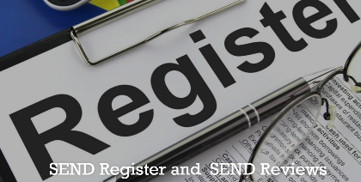

If your child is on our SEND register, they have an updated Support plan for this academic year including their new smart targets. You should have a paper copy of these targets and they will be reviewed with you at the parents evening in March.
Do you think your child should be on the SEND Register? Email me at school, (hthompson@jamescambellprimary.org.uk) I would love to chat this through with you. I will then spend some time doing further information gathering with the class teacher and professionals. This is part of the Graduated Approach in the SEN Code of Practice. This typically takes around 2-6 weeks. After that, I will speak with you again to discuss next steps for your child. Sometimes this means they go onto the SEND Register. Sometimes it means that they continue to be monitored and we continue to review their needs.

Parent SENDCO Surgery: Starting January 2023
From January I will be starting some parent surgery times where you can book a 20 minute appointment to come and see me in school. These will be every Wednesday and Friday 2.00 - 3.00pm during term time. Appointment times: 2.00pm 2.20pm 2.40pm
Please book an appointment to:
· Share any information updates
· Review your child’s progress or discuss any issues or concerns
· Review provision/interventions
Please take advantage of this opportunity to positively review and share information about your child’s SEN requirements.
Contact Mrs Thompson (SENDCO) to arrange a surgery appointment via hthompson@jamescambellprimary.org.uk
Appointment only

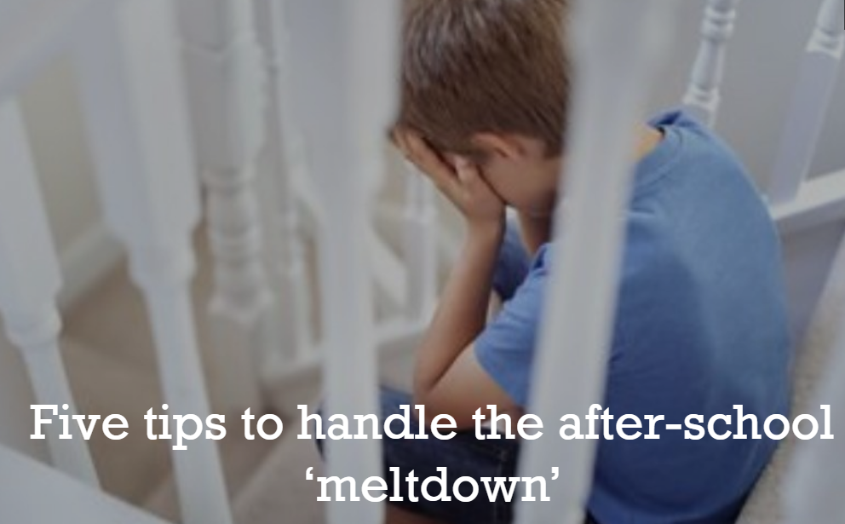

Five tips to handle the after-school
Picture the scene: your child comes out of school and the teacher says they’ve behaved like
the perfect child all day, but the moment you get home they have a complete meltdown.
Picture the scene: your child comes out of school and the teacher says they’ve behaved like the perfect child all day, but the moment you get home they have a complete meltdown. Your child screams, shouts, lashes out, sulks or generally acts in an unruly manner.
If that scene is familiar to you, you’re not alone. This type of behaviour is what some psychologists refer to as ‘after-school restraint collapse’ and it’s not unusual. It happens because your child has been busy managing their emotions all day as they navigate the complexities of school life.
Parents’ Toolkit from BBC Bitesize has been speaking to educational and child psychologist Dr Anisa-Ree Moses, for some tips on how to handle these outburst of emotions after-school.
Five tips to handle the after-school ‘meltdown’

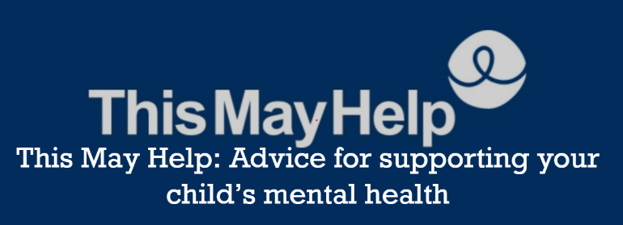
THIS MAY HELP is a new website for parents and carers who have concerns about their
THIS MAY HELP is a new website for parents and carers who have concerns about their child's mental health.

Trigger warning: Topics covered include: self-harm, gaming and online activity, eating disorders, school avoidance, understanding mental health, online threats, building rapport, building resilience, building a support network, self-care tips, managing an emergency, managing in a crisis, and preparing for a children and adolescent mental health services (CAMHS) appointment. You can access it at https://thismayhelp.me/

Barking & Dagenham Local offer
For more information on how the borough can help if you have a child with SEND please see:
Local offer | London Borough of Barking and Dagenham (lbbd.gov.uk)

